

The Certificate is personalized to

Muhammad Saad

Nazish Iqbal

Tariq Ahmed

The successfully design & developed on Master Mind Game AAP

E- Project of HDSE 2 (4th Semester)

APTECH Worldwide Computer Education

Shahrah-e-Faisal Center, Karachi

Members

Design & Developed by:

Muhammad Saad

Nazish Iqbal

Tariq Ahmed

Supervision By:

Miss Huda



ACKNOWLEDGMENT

Acknowledgment is not more formality but a genuine opportunity to thank all Those people without that active support in this project would not be able to be Possible We are thankful to almighty Allah with his grace and mercy for giving us strength Good sense and confidence to complete the project successfully we presenting on “Master Mind Game” in your hands, we have tried our best to take all relevant and important topics in consideration so that this project may become more effective and a batter outlook to come. This project has been developed with the help of “XML /Java” I would like to acknowledge all those who have given moral support and helped me to Make this project a success. I wish to express my gratitude to Miss Huda For his valuable guidance and support for the completion of this project.

And finally. I would like to offer many thanks to all my colleagues for their valuable

Suggestions and constructive feedback.

Project Synopsis

# Master Mind Game

Master mind is a game which keep test to your mind. This is a mind game. We have already heard about the similar kind of games based on word puzzle. This is a more complex game to all such game. In this game the words were very complex and useful to improve the student’s vocabulary and reading skills.

Words are in jumble format which we need to re-arranged in order to score best. As the words word are complex we would provide the player with a hint beforehand only. Here we have three levels in this game are easy, medium, and hard. These levels are based on time.

**PROPOSED SYSTEM**

Our Android Project name is “Mastermind game”. The main advantage by playing this game we can improve our vocabulary. In this first one jumbled word is displayed on the screen, using the letters of the jumbled word we have to write the correct meaningful word in the box provided. If we write the correct word the score is displayed in the right side of the screen. For one correct word the user get ten points. If we write wrong word then another jumbled word is replaced. The time provided for this game as per the difficulty levels. After finishing the time it asks as we want to quit or try again.

In this the option of selecting the difficulty of the game are easy, medium, hard three levels are present. In the easy level the words which are displayed are easier when compare to other two levels. In the medium level the words are slightly difficult when compare to easier level. In the hard level the words are harder when compare to other two levels.

**Admin:**

* Create three levels
* Adding words to game based on difficulty levels
* Check user wise reports.
* Add/Update user credentials.
* Maintain scores.

**User:**

* Register for the game with proper details
* Play game
* See self-score and top score of the game/level.

**Hardware/ Software Requirements**

**Hardware**

* Android mobile with a minimum version 2.2.
* The processor is not less than 500MHZ.
* RAM is not less than 2048MB.
* SD card with a minimum of 512MB.
* Resolution is not less than 480*800pixs.

**Software**

Use software as per your requirement

* Windows OS/JAVA/Android SDK/Notepad/SQL/Android 2.2 or Later

1. Admin Dashboard

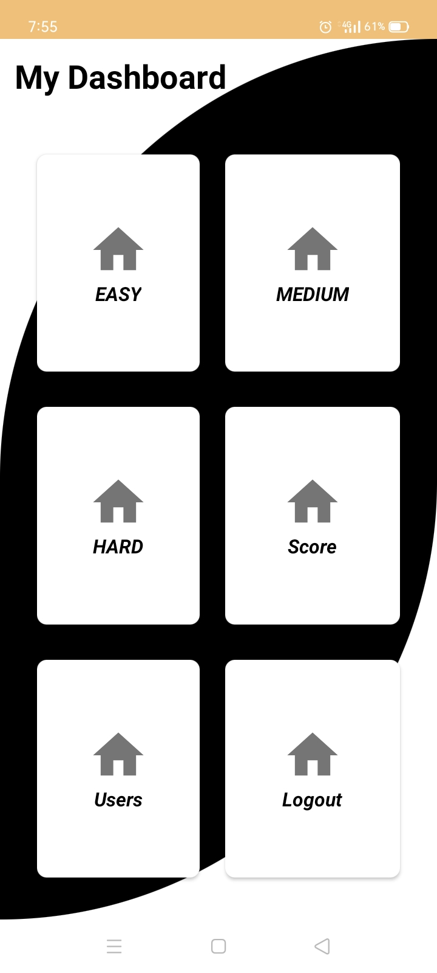

2. Hard Words

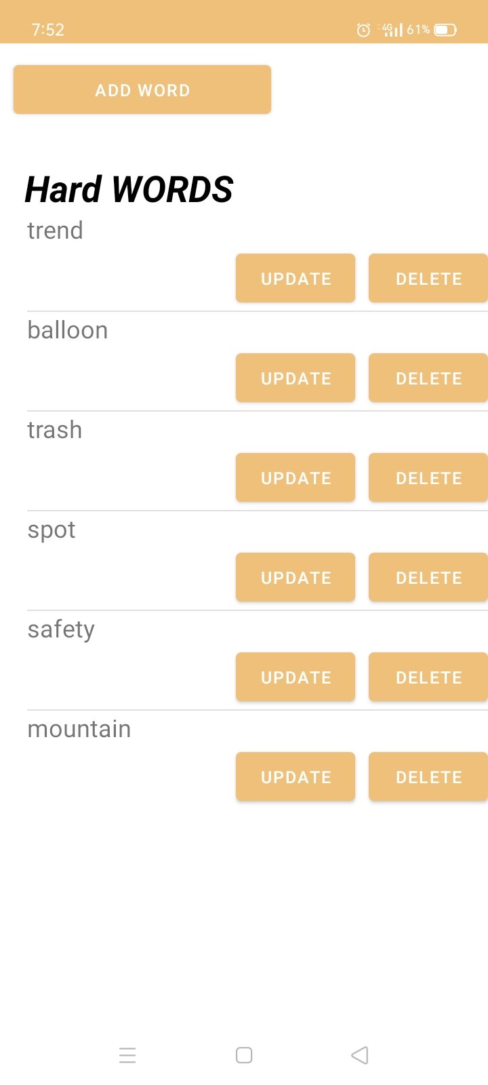

3. Easy Words

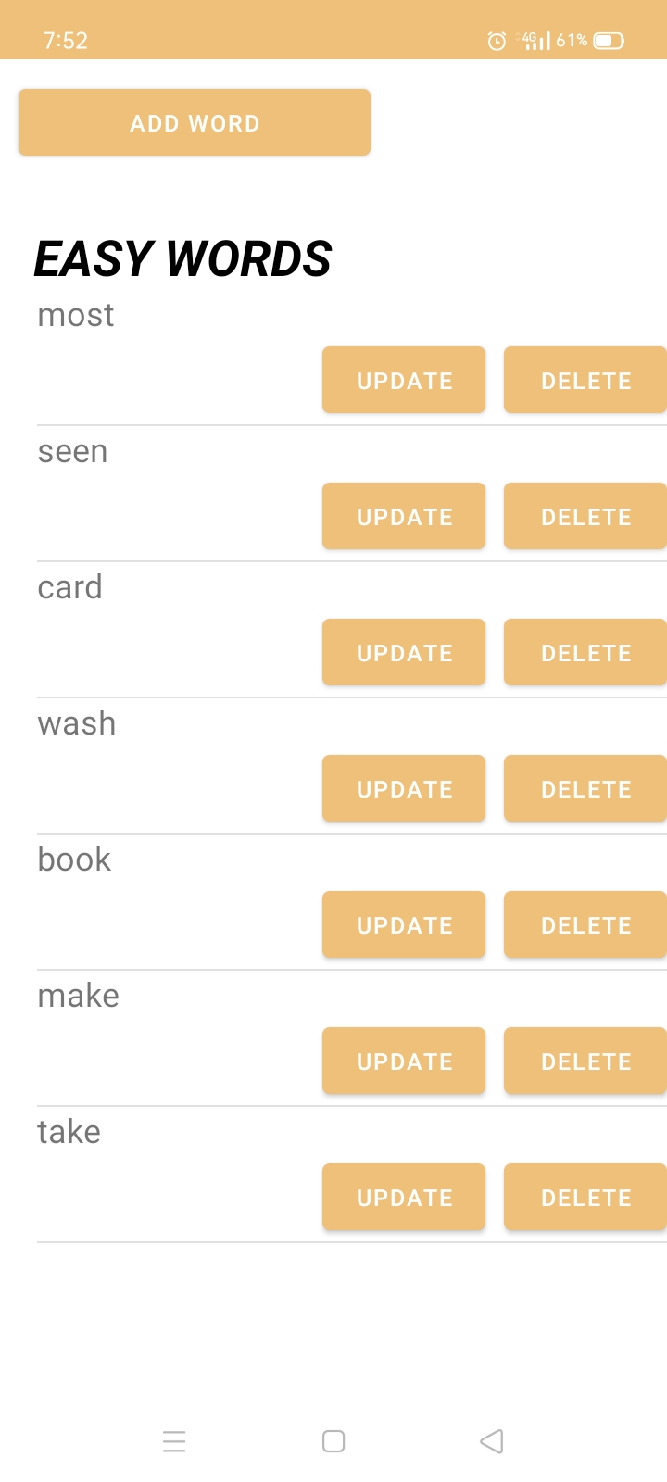

1. Medium Words

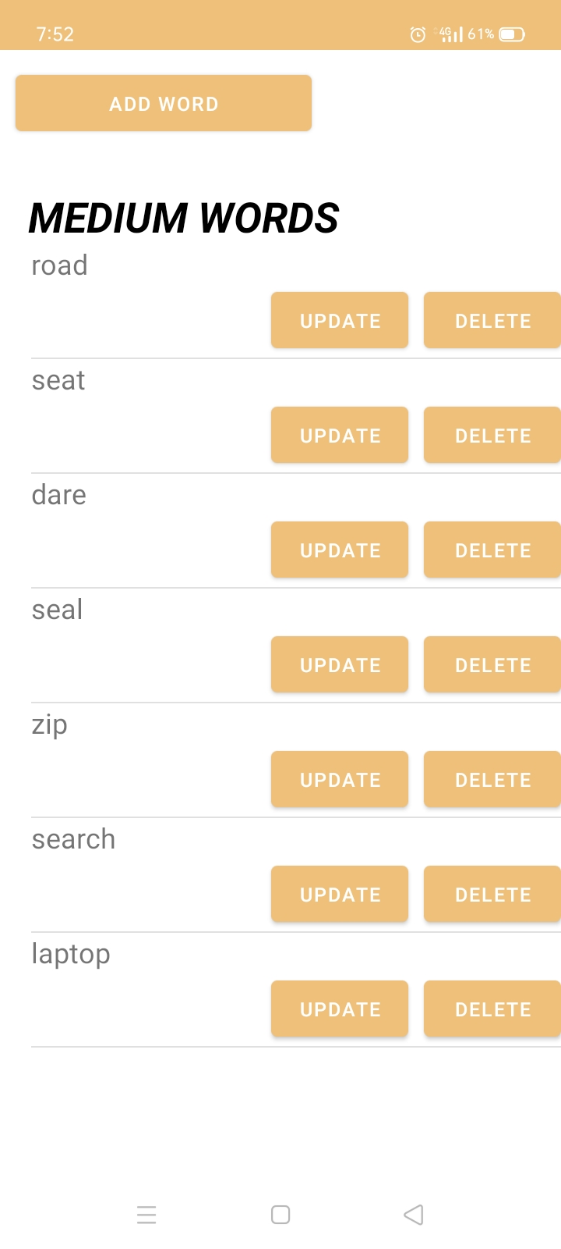

User’s Details

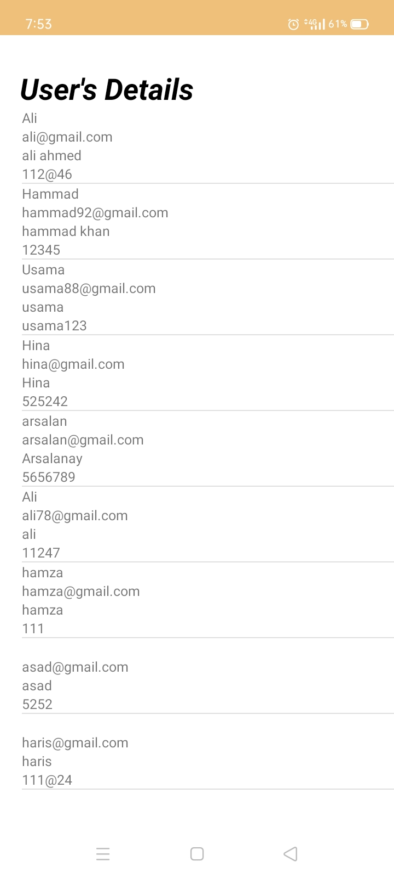

1. Update Hard

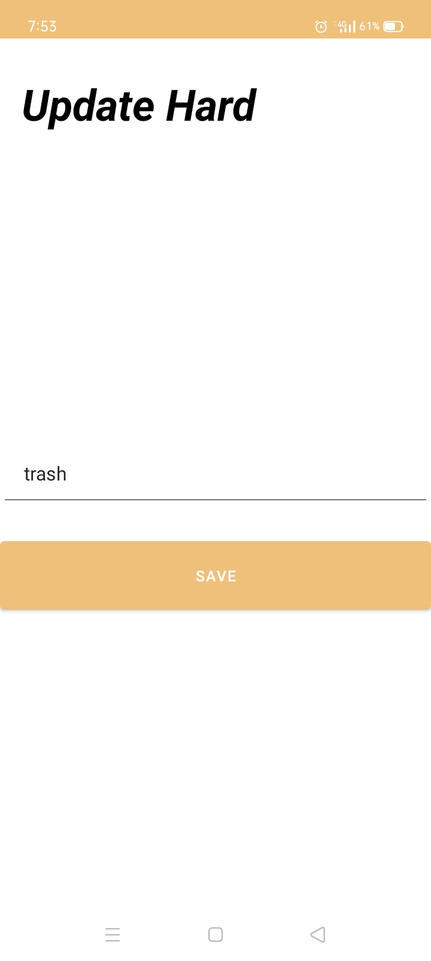

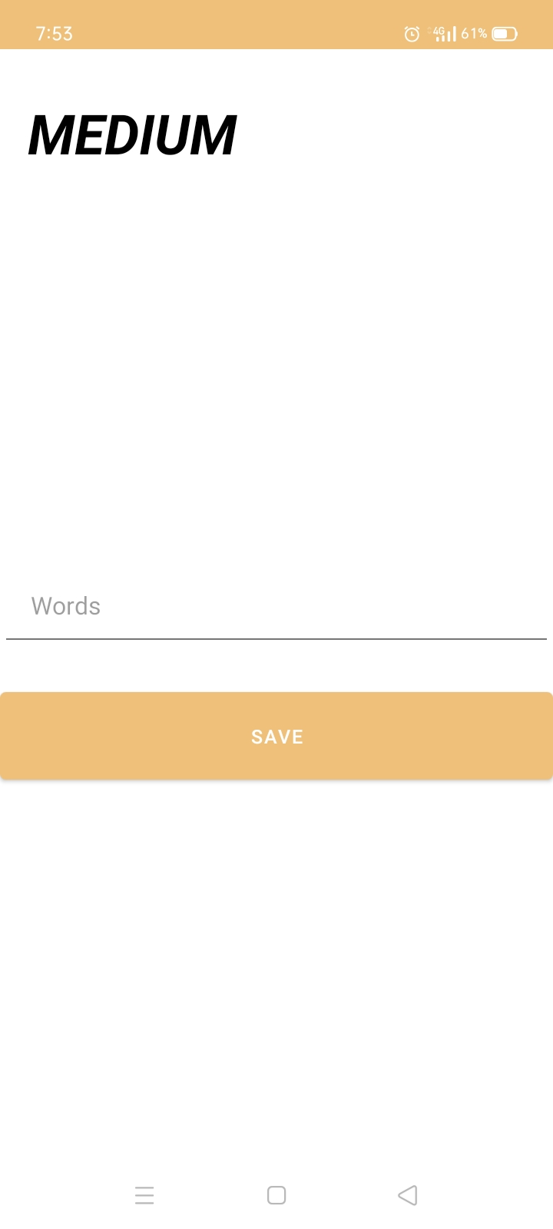

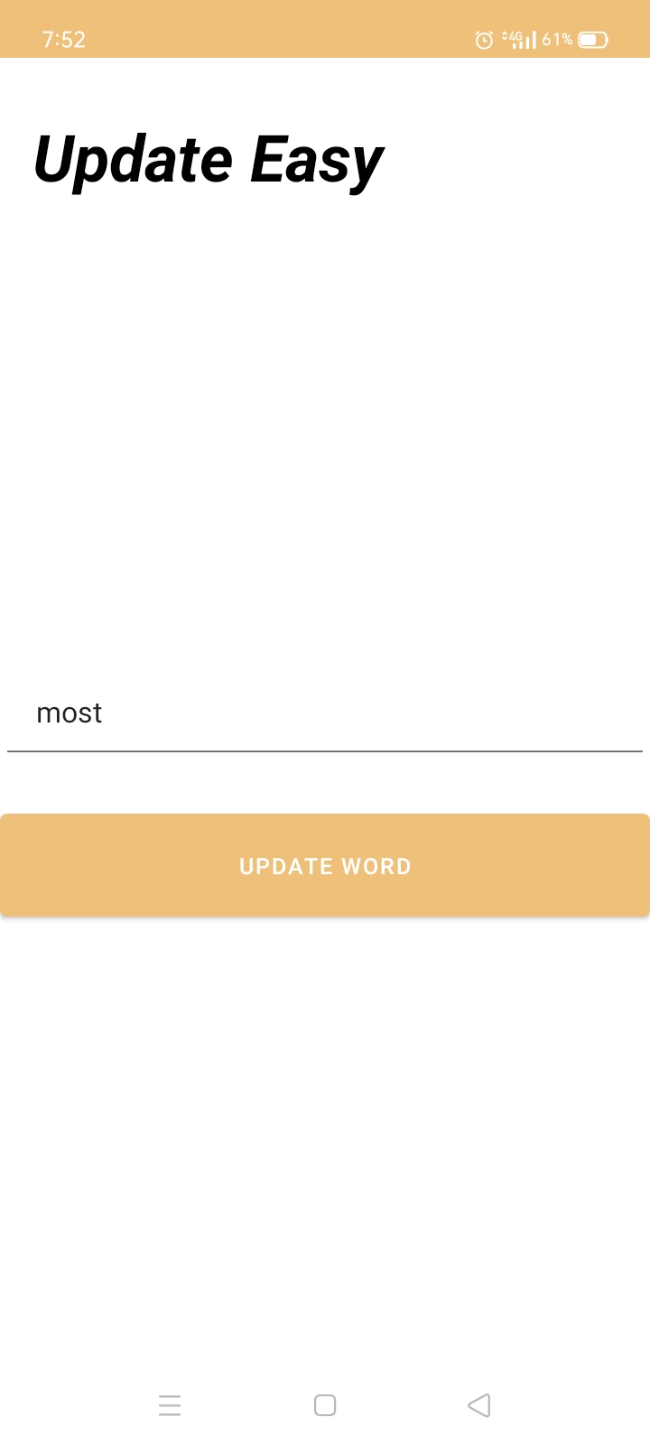



Thank

You